Computer System Architecture

CHAPTER-1

Basicstructureofcomputerhardware

ComputerArchitecture
In computer engineering, computerarchitecture isasetofrulesandmethodsthat describe the functionality, organization, and implementation of computer systems

Functionalunit
- Acomputerconsistsoffivefunctionallyindependentmainpartsinput,memory, arithmetic logic unit (ALU), output and control unit.
- Inputdeviceaccepts thecodedinformationassource programi.e., highlevel language.
- Thisis either stored in the memory or immediately used by the processor to perform the desired operations.
- Theprogramstoredinthememorydeterminestheprocessingsteps.
- Basically, the computer converts one source program to an object program. i.e., intomachine language.
- Finally,the results are sent to the outside world through output device. All of theseactions are coordinated by the control unit.
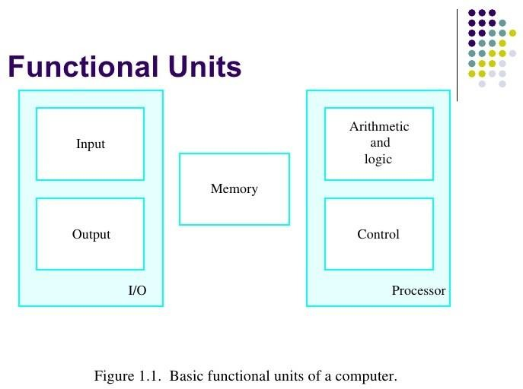
Inputunit:-
- The source program/highlevellanguage program/codedinformation/simply data is fed to a computer through input devices keyboard is a most common type.
- Wheneverakeyispressed,onecorrespondingwordornumberistranslatedintoits equivalent binary code over a cable & fed either to memory or processor.
- Example–Keyboard,Joysticks,trackballs,mouse,scannersetcareotherinputdevices.
Memoryunit:-
Itsfunctionistostoreprogramsanddata.
Itisbasicallytotwotypes1.Primarymemory2.Secondarymemory
Primarymemory:-
  - Istheoneexclusivelyassociatedwiththeprocessorandoperatesathighspeed.
  - Thememorycontainsalargenumberofsemiconductorsstoragecells.
  - Theseareprocessedina groupoffixedsizecalledword.

  - Programs must reside in the memory during execution. Instructions and data can bewritten into the memory or read out under the control of processor.
  - Secondarymemory:-
  - Thistypeofmemoryisusedwherelargeamountsofdata&programshavetobe stored, particularly information that is accessed infrequently.
  - Examples:-Magneticdisks&tapes,opticaldisks(i.e.,CD-ROM’s),floppiesetc.

Arithmeticlogicunit(ALU):-
Most of the computer operation are executed in ALU of the processor like addition, subtraction, division, multiplication, etc. The operands are brought into the ALU from memory and stored in high-speed storage elements called register.

Controlunit:-
The operations of all the units are coordinated bythe control unit i.e., it acts as a nerve centre that sends signals to other units and senses their states. The actual timing signals that govern thetransferofdatabetweeninputunit,processor,memoryandoutputunitaregenerated by the control unit.

Outputunit:
These are actually are the counterparts of input unit. Its basic function is to send theprocessed results to the outside world after processing. Examples: - Printer, speakers, monitor etc.

BusStructure
A bus is a communication system that transfers information (in any form like data, address or control information) between components, inside a computer, or between computers.
  - Itisthe groupofwirescarryingagroupofbitsinparallel.
  - Therearethreekindsofbusaccordingtothetypeofinformationtheycarrylike
    - DataBus
    - AddressBus
    - ControlBus
  - A bus which carries a word from or to memory ate called Data bus. It carries the data from one system module to other. Data bus may consist of 32,64, 128 or even more numbers of separate lines. This number of lines decides the width of the data bus.Each line can carry one bit at a time. So, a data bus with 32 lines can carry 32bit at a time.
  - Address Bus is used to carry the address of source or destination of the data on the data bus.
  - ControlBusisusedtocontroltheaccess,processingandinformationtransferring.

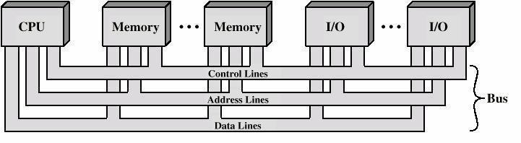

- Inthismethodbusarchitecture,theprocessorwillcompletelysuperviseandparticipate in the transformation.
- The information will be first taken to the processor register and then to the memory such that transfer is known as program-controlled transfer.
- The interconnection between i/o unit, processor and memory accomplished by two independent system bus is known as two-way bus interconnection structure.
- The system bus between i/o unit and processor consist of DAB (Device address bus), DB (Databus),CB (Controlbus). Similarly, the systembus betweenmemory processor consists of MAB (Memory address bus), DB, CB.
- Thecommunicationexistsbetween
- Memorytoprocessor
- Processortomemory
- I/otoprocessor
- processortoi/o
- I/otomemory

Performancemeasures:-
Performanceistheabilityofthecomputertoquicklyexecuteaprogram.
- Thespeedatwhichthecomputerexecutesaprogramisdecidedbythedesignofits hardware and machine language instruction.
- Computer performance measures is of very big term when used in context of the computer system.
- Systemthatexecutesprograminlesstimearecalledtohavehigherperformance.
Basicperformancemeasures:-
Thespeedofoperationofasystemisgenerallydecidedbytwofractions.
- Responsetime
- Throughput.
ResponseTime:-
  - Responsetimeisthetimespendtocompleteaneventoranoperation.
  - Itisalsocalledasexecutiontimeorlatency.
Throughput:-
Throughput is the amount of work done per unit of time. i.e., the amount of processing that can be accomplished during a given interval of time.
  - Itisalsocalledasbandwidthofthesystem.
  - Ingeneral,fasterresponsetimeleadstobetterthroughput.

Elapsedtime:-
  - Elapsed time is a time spent from the start of execution of the program to its completion is called elapsed time.
  - Thisperformancemeasureisaffectedbytheclockspeedoftheprocessorandthe concerned input output device.

MIPS
  - Anearlymeasureofcomputerperformancehastherateatwhichagivenmachine executed instruction.
  - Thisiscalculatedby dividing theno. ofinstructionandthetimerequiredtorunthe program.

CPI/IPC
  - CPI–ClockcycleperInstruction,IPC–Instructionpercycle.
  - It is another measuring that which is calculated as the number of clock cycle required to executeone instruction (cycle per instruction)by theinstruction executed per cycle.
Speedup:-
  - Computer architecture use the speed up to describe the performance of architectural changes as different improvement are made to the system.
  - Itisdefinedasratioofexecutiontimebeforetotheexecutiontimeafterthecharge.
  - Speedup=executiontimebefore/Executiontimeafter

Amdahl’slaw:-
  - This law states that “performance improvement to be gained by using a faster modeof execution is limited by the fraction of time the faster mode can be used”.
  - Amdahl’slawdefinesthetermspeedup.
  - Speedup=performanceofentiretaskusingenhancement/Performanceofentire task without using enhancement
  - Performance=1/Executiontime
  - Speedup=executiontimewithoutusingenhancement/Executiontimewithusing enhancement
  - Factorsaffectingspeedupareasfollows:
    - The fraction of computation time in the original machine can be modified to use the advantage of the enhancement. This is called fraction enhanced which isalways less than or equal to one.
Fractionenhanced≤1
    - Improvement granted by the enhanced execution made is the speed with which the task could run faster using the enhancement.
Speedup>1
  - Speedupenhanced=timeinoriginalmode/Timeinenhancemode
  - Ex.Let usaprogramtakes 5 second in enhancedmodewhile ittakes 10 secondearlier. So, speedup enhanced = 10/5 = 2

  - Thenewexecutiontimecanbecalculatedasfollow:
  - Executiontimenew=ExecutiontimeoriginalX((1-fractionenhanced)+fraction enhanced/speedup enhanced)
  - Thespeedupoverall=executiontimeoriginal/executiontimenew
  - Speedupoverall=1/((1-fractionenhancement)+fractionenhance/Speedupenhance)
Performanceparameter
  - ThebasicperformanceequationisgivenbyT=(NxS)/R
  - WhereT–Performanceparameterofanapplicationprogram.
  - N–No.ofinstructionrequiredtocompletetheexecutionofa program.
  - S–Averagenoofsteps toexecuteaninstruction.
  - R-Clockrateoftheprocessorincyclespersecond.
Clockrate:-
  - Clockrateisoneoftheimportantperformancemeasures byimprovingintheclock rate. There are two ways in which clock rate may be increased.
  - ImprovingIC technology which makes logic circuits faster thus reading time taken to complete a basic step.
  - Byreducingtheprocessingamountinonebasicstepwhichbyreducestheclock period as R = 1/T.
CPUperformanceEquation:-
  - Normally theCPUsareconstructedby usingaclockrunningataconstantrate.This discrete time event is known as a clock cycle.
  - CPUtime=CPUclockcycleforaprogramxclockcycletime
• =CPUclockcycle/clockrate
  - ICXCPIXC
Pipeliningandparallelprocessing
Theperformanceofthesystemcanbeimprovedsubstantiallybyoverlappingtheexecution of successive instruction. This technique is called as pipelining. Parallel processing can also be implemented to achieve the high performance instead of traditional sequential processing.

Memoryaddressing
Themaximumsizeofthememorythatcanbeusedinanycomputerisdeterminedbythe addressing scheme.
For ex- a 16-bit computer that generates a 16-bit address is capable of addressing up to 2¹⁶k memory location.
The no of location represents the size of the address space of computer. Most modern computers are byte addressable computer.

CHAPTER-2
Instructions&instructionSequencing

Introduction
The instruction set defines many of thefunction performed bythe CPU and plays a significant role in the implementation of the CPU.
Thefactorstobetakenintoaccountwhile designingan instructionsetare:
- OperationRepertoire
This gives an idea how many &what kindof operationneed to beprovided and also the complexity of such operation.
- Datatype
Information needs to be provided on the various types of data & operation to be performed on them.
- Formatofinstruction
This includes the length of the instruction inbits, numberof addresses to be used with the instruction and the size of each field in the instruction.
- Register
The number of CPU register that can be accessed by instruction for storage of data & operands.
- Addressingmode
The instructionsetalso specifies addressingmethodsfor accessingoperands either in the memory or in the processor register.

TypesofOperands
Machine operationdependonthetypesofdatabeingprocessed.
Thedifferentformatofdatatobeusedwithassemblyandhigh-levellanguage program are as follows
1.Address 2.Number 3.Character
4.Logicaldata

Address
  - Addressisaformof numbersthatrepresentspecificlocationinthememory.
  - Address maybeconsideredasunsignedinteger.
Number
  - Numericdatatypesareusedbyallmachine language.
  - Threetypesofnumericaldataarecommonlyused:
- Integer orFixedpoint
- Floatingpoint
- Decimal
Character
Another common form of data is represented in a program are character string. As it cannot be stored or processed so these form of data are coded by any of the conversion method like IRA,ASCII,EBCDIC.
Logicaldata
  - Thisisthebit-orientedviewof data.
  - These types of data can be represented as an array of Boolean or binary data items (1 for T and 0 for F).
AddressingModes
  - The operand field of an instruction specifies the address from where the data has to be fetched.
  - Thismaybeamemoryaddress,registerormaybea directvalue.
  - Theoperandchosenis dependentontheaddressingmodeoftheinstruction.
Themostcommonaddressingtechniquesare
  - Immediate
  - Direct
  - Indirect
  - Register
  - RegisterIndirect
  - Displacement
  - Stack

ImmediateAddressing:
The simplest formof addressing is immediateaddressing,inwhichthe operand is actually present in the instruction:

OPERAND=A
The advantage of immediate addressing is that no memory reference other thanthe instruction fetch is required to obtain the operand.
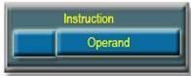

DirectAddressing:
  - A very simple form of addressing is direct addressing, in which the address field specifies the address of the memory location.
  - Itrequiresonlyonememoryreferenceandnospecialcalculation.
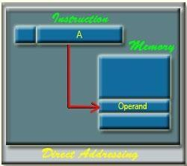
Ex-LDA2500

IndirectAddressing:
  - The address field of the instruction uses the address of the operand stored in the memory.
  - Theeffectiveaddressoftheoperandisgivenbytheaddresspartofthe instruction.
EA=(A)
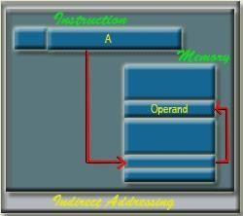

RegisterAddressing:
  - Registeraddressingissimilartodirectaddressing.
  - The only difference is that the address field refers to a register rather than a main memory address

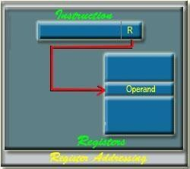
Ex-MOVAB

RegisterIndirectAddressing:
Register indirect addressing is similar to indirect addressing, except that theaddress field refers to a register instead of a memory location.
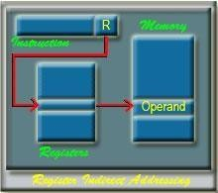

DisplacementAddressing:
Averypowerfulmodeofaddressingcombinesthecapabilitiesofdirect addressing and register indirect addressing, which is broadly categorized as displacement addressing:

EA=A +(R)
Threeofthemostcommonuse ofdisplacementaddressingare:
- Relativeaddressing
- Base-registeraddressing
- Indexing
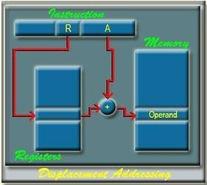

RelativeAddressing:
  - Inthismodetheinstructionspecifiestheoperandaddressastherelative position of the current instruction address i.e., content of PC.
  - ThecurrentinstructionaddressisaddedtotheaddressfieldtoproduceEA.

Base-RegisterAddressing:
In thismode the referenceregister containsamemory address,andthe address field contains a displacement from that address.

Indexaddressing:
  - Inthismodeanindexregistercontainsthe offset value.
  - The instruction contains the address that should be added to the offset in the index register to get the effective address.
Instruction format
An instruction format defines the layout of the bits of an instruction in an instruction set.
Usuallythereareseveralinstructionformatsinaninstructionset.
- An operationcode:-Thisspecifiestheoperationtobeperformed.
- Source operand :- The operand specified by the opcode may involve one or more sources for operand, these act as the input for the operation.
- Resultantoperand:-Afterprocessingthe resultmusthavetobe storedinan

operand.
- Next reference instruction:-This fieldtells theCPU from where the nextinstruction is to be fetched after the execution is completed.

ThreeaddressInstruction
Computer withthree addressesinstruction formatcanuseeach addressfieldto specify either processor register or memory operand.

ADD | R1,A,B | R1® M[A]+ M[B]
ADD | R2,C,D | R2® M[C]+M[D] | X=(A+ B)*(C+A)
MUL | X,R1,R | M[X]R1*R2
  - The advantage of the three address formats is that it results in short program when evaluating arithmetic expression.
  - The disadvantage is that the binary-coded instructions require too many bits to specify three addresses.

TwoAddressInstruction
  - Mostcommonincommercialcomputers.
  - Eachaddressfieldcanspecifyeitherprocessesregisteroramemoryword.
MOVR1,A R1®M[A]
ADD R1,B R1®R1+M[B]
MOVR2,C R2®M[C] X=(A+ B)*(C +D)
ADD R2,D R2®R2+M[D]
MULR1,R2 R1®R1*R2
MOVX,R1 M[X]®R1

OneAddressinstruction
Itused animpliedaccumulator(AC)registerforalldatamanipulation.For multiplication/division, there is a need for a second register.

LOADA | AC®M[A]
ADD B | AC®AC+ M[B]
STORET | M[T]®AC | X=(A+B)×(C+A)
  - Alloperationsare donebetweentheACregisterandamemoryoperand.
  - It’stheaddressofatemporarymemorylocationrequiredforstoringthe intermediate result.
LOADC AC®M(C)
ADD D AC®AC+M(D)

ML T AC®AC*M(T)
STOREX M[X]®AC

ZeroAddressInstruction
A stack organized computer does not use an address field for the instruction ADD and MUL. The PUSH & POP instruction, however, need an address field to specify the operand that communicates with the stack (TOS ® top of the stack)
PUSHA TOS®A
PUSHB TOS®B
ADD TOS®(A+B)
PUSHC TOS®C
PUSHD TOS®D
ADD TOS®(C+D)
MUL TOS®(C+D)*(A+B)
POP X M[X]TOS

INTRODUCTION

CHAPTER-3

ProcessorSystem

- The part of the computer that performs the bulk of data processing operation is called the central processing unit, CPU.
- TheCPUismadeupofthreemajorparts-
  - ALU: - Arithmetic Logic Unit performs the required microoperation for executing the instruction.
  - RegisterSet:-Storestheintermediatedatausedduringtheexecutionofinstruction.
  - Control Unit: - Supervises the transfer of information among register and ALU by sending suitable control signal.

Controlunit
The Control Unit (CU) is the heart of the CPU. Every instruction that the CPU supports has to be decoded by the CU and executed appropriately. Every instruction has a sequence of microinstructions behind it that carries out the operation of that instruction
- Anydigitalsystemconsistsof2units
  - Dataprocessor
  - Controllogic
- Dataprocessorconsistsofindividualregisterandallfunctionalunit.
- Controllogicinitiatesallmicro-operationinthedataprocessor.
- Controlunitgeneratescontrolsignalwhichinitiatessequenceofmicro-operation.
- By issuing control signal which micro-operation are activated are represented as sequence of 1s and which are not activated represented as 0s.
- Traditionally there are two general approaches to implement a control and decode unit for a CPU :
  - HardwiredcontrolUnit
  - MicroprogrammedcontrolUnit

Hardwiredcontrolunit
- Inthehardwiredorganization,thecontrollogicisimplementedwithgates,flipflop, decoder and other digital circuits.
- Ithastheadvantagethatitcanbeoptimizedtoproduceafastmodeofoperation.
- Ahardwiredcontrolforallthebasiccomputerisshownintheabovefigure.
- The hardwired control unit consists of 2 decoders, a sequence counter and a number of control logic gates.

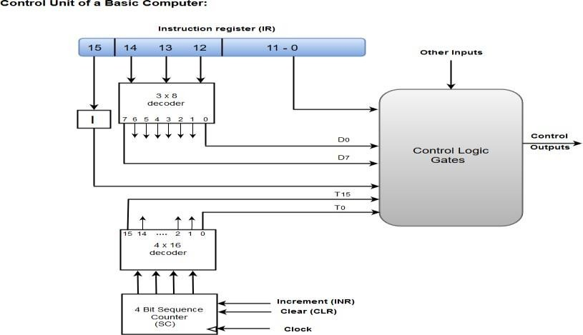

- TheinstructionfetchedfrommemoryisplacedinIR(instructionregister).TheIRis divided into 3parts. The I bit, the operation code and bits 0-11.
- Theopcode12-14aredecodedwitha3×8decoder.theeighto\pofthedecoderare designated by the symbol D0-D7.
- The subscripted decimal is equivalent to the binary value of the correspondingoperation code.
- Bits0-11areappliedtothecontrollogicgates.
- The4-bitSC(sequencecounter)isdecodedinto16timingsignalsthroughT0-T15.
- TheSCcanbeincremented/clearedsynchronously.
- Allthese inputslike0-11ofIR,decodedopcodefromD0-D7,theo/pofIflipflop,the timing signal T0-T15and other input are given to control logic gates.
- These control logic gates decide the states of I/p and provide the appropriate control signal and timing signal.
- Dependingonthiscontrolsignal,theALUtakestheappropriateaction.

Microprogrammedcontrolunit
- EveryinstructioninaCPUisimplementedbyasequenceofoneormoresetsof concurrent micro-operation.
- Eachmicro-operationisassociatedwithaspecificsetofcontrollineswhichwhen activated cause the micro-operation to take place.
- Hereto generate the control signal, theCUexecute aseries ofsequential steps ofmicro- operation.
- The control variable at any given time can be represented by a string of 1s or 0s called control word.
- Inmicroprogrammedthebinarycontrolwordsarestoredinmemorycalledcontrol memory.
- Thecomputerwhichemploysmicroprogrammedcontrolpossess2separatememories
:1)Mainmemory2)Controlmemory

- Main memory is available for storing program. content of main memory may alter bychanging the program.
- Eachmachineinstructioninmainmemoryinitiatesaseriesofmicroinstructionin control memory.
- Microinstructiongeneratesmicro-operationsuchasfetchinstructionfrommain memory, calculate effective address, fetch operand, execute the operation etc.
- Eachcontrolwordincontrolmemorycontainswithinitamicroinstruction.
- Asequenceofmicroinstructionconstitutesamicroprogram.
- For a particular control signal a particular micro program is written, since there is no needtochangethemicroprogramstoredincontrolmemory,thecontrol memorycan be stored in ROM.
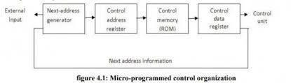
- So, to execute a micro program stored in control memory to get the appropriate control word for generation of control signal, the following operation is to be done.
- The control memory address specifies the address of micro instruction & the controldata register holds the microinstruction read from memory.
- Themicroinstruction contains a control word that specifies one or more micro-operation for the data processor, once these operations are executed , the control must determine the next address.
- Thenextaddressmayalsobeafunctionofexternalinputcondition.
- The next address generator is a circuit that generates the next address which is then transferred into the control address register to read the micro instruction.
- Thenextaddressgeneratorsometimescalledasmicroprogramsequencer.

REGISTERFILES: -
- MostmodernCPUshaveasetofgeneralpurpose(GPRs)registerR0toRn-1called register files.
- Each register Rm in RF is individually addressable with address subscript m. Example: - R2=f (R1, R2)
- Thiswaytheprocessorisabletoretainintermediateresultsinfastandaccessible registers rather than external memory M.
- For accessing RF needs several ports for simultaneous reading and writing purposes, so it is often realized as a ‘multiport RAM.’
- A multiport RF is built using a set of registers of proper size and multiplexer- demultiplexer.

- Thereadoperationcantakeplacethroughseveraldevicesreadingfromthesame register using different ports though the writing is normally done through one port only.
- The above RF shows a three port, where simultaneous read can occur from port A and port B and writing takes place using port C.

CompleteinstructionExecution
TheCPUexecuteseachinstructioninaseriesofsmallsteps:
- fetchthenextinstructionfrommemorytheinstructionregister(IR).
- changetheprogramcounter(PC)topointtothefollowinginstruction.
- Decodetheinstructionjustfetched.
- Iftheinstructionusesdatainmemorydeterminewheretheyare.
- Fetchthedataifany,intointernalCPUregister.
- Executetheinstruction.
- Storetheresultintheappropriateplace.
- Gotostep1tobeginexecutingthefollowinginstruction.

Thisabovesequenceofsteps(micro-operation)isfrequentlyreferredtoasthefetch- decode-execute cycle or instruction cycle.
During an instruction cycle, the action of the CPU is defined by the sequence of microoperation it executes.
ThetimerequiredbytheCPUtoexecuteamicrooperationistheCPUcycletimeorclock period.

DESIGNOFALU:-
- Thecircuitswhichcarryoutthedataprocessinginstructions,istheALU.
- ThecomplexityoftheALUdependuponhowtheinstructionarerealized.
- TheALU using combinational circuits can perform fixed point arithmeticas well as word based logical operation.
- Someextracontrollogicandsomeextensivedataprocessingcircuitscalledasco- processor are employed to perform floating point operation.

COMBINATIONALALU:-
- ThesimpleALUcombinesthebothfeaturesof2’scomplementaddedsubtractorand word-based logic unit.
- ThecombinationalALUisnothingbutacombinationofcombinationalcircuitsand multiplexer.

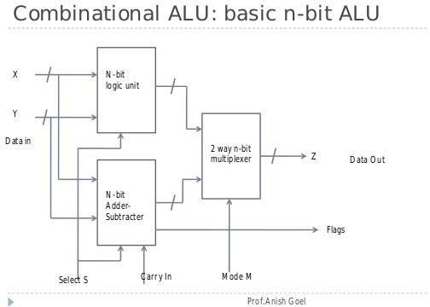

Theabovefigureshows that: -
- Mode control line attached to the two-way n bit multiplexer determines the type of operation i.e., logical or arithmetic.
- The select line S determines the specific operation to be performed by the desired sub unit.
- As the select line is of 4 bits, we can get 16 different logical and also 16 different arithmetic operation.
- Example:-bytakingthevaluesofM,thefourcombinationsare

M3=xiyi M2=xiyi M1=xIyi M0=xiyi
F (x,y) =M3S3+M2S2+M1S1+ M0S0
=xiyiS3+ xi yiS2+xIyiS1+ xiyiS0
- So, for every combination of S3, S2, S1 and S0 we will get a different operation. ADVANTAGE: -
ThistypeofALUismuchsimpler.
DISADVANTAGE:-
- Itismoreexpensive.
- Itismuchslower.

Memorycharacteristics

CHAPTER-4

MemorySystem

The memory unit is the essential component in any computer since it is needed for storing the program and data.
Thememorysystemisclassifiedaccordingtotheirkeycharacteristicslike:

- Location
- Capacity
- UnitofTransfer
- AccessMethod
- Performance
- Physicaltype
- Physicalcharacteristics

- Location:
It deals with thelocation ofthememory devicein thecomputer system. Therearethree possible locations:

  - CPU:Thisisofteninthe formofCPUregistersandsmall amountofcache
  - Internalormain:ThisisthemainmemorylikeRAMorROM.TheCPUcandirectlyaccessthe mainmemory.
  - Externalorsecondary:Itcomprisesofsecondarystoragedeviceslikeharddisks,magnetic tapes. TheCPU doesn’taccess these devices directly. It uses device controllerstoaccess secondary storage devices.

- Capacity:
Thecapacityofanymemorydeviceisexpressedintermsof:i)wordsizeii)Numberofwords
Word size: Words are expressed in bytes (8 bits). A word can however mean any number of bytes. Commonly used word sizes are 1 byte (8 bits), 2bytes (16 bits) and 4 bytes (32 bits).
Number of words: This specifies the number of words available in the particular memory device. For example, if a memory device is given as 4K x 16.This means the device has a word size of 16 bits and a total of 4096(4K) words in memory.
- UnitofTransfer:
It is the maximum number of bits that can be read or written into the memory at a time. In case ofmainmemory,itismostlyequaltowordsize.Incaseofexternalmemory,unitoftransfer is not limited to the word size; it is often larger and is referred to as blocks.

- AccessMethods:
It is a fundamental characteristic of memory devices. It is the sequence or order in which memory can be accessed. There are three types of access methods:

  - RandomAccess:Ifstoragelocationsinaparticularmemorydevicecanbeaccessed in any order and access time is independent of the memory location being accessed.Such memory devices are said to have a random-access mechanism. RAM (Random Access Memory) IC’s use this access method.
  - Serial Access: If memory locations can be accessed only in a certain predetermined sequence, this access method is called serial access. Magnetic Tapes, CD-ROMsemploy serial access methods.
  - Semi random Access: Memory devices such as Magnetic Hard disks use this access method.Here each trackhasaread/writehead thuseachtrack can beaccessed randomly but access within each track is restricted to a serial access.
- Performance:
Theperformanceofthememorysystemisdeterminedusingthreeparameters
  - Access Time: In random access memories, it is the time taken by memory to complete the read/write operation from the instant that an address is sent to the memory. For non- random access memories, it is the time taken to position the read write head at the desired location. Access time is widely used to measure performance of memorydevices.
  - Memorycycletime:ItisdefinedonlyforRandomAccessMemoriesandisthesum of the access time and the additional time required before the second access can commence.
  - Transfer rate: It is defined as the rate at which data can be transferred into or out of a memory unit.
    - Forarandom-accessmemory,itisequalsto1.
    - For a non-random access memory, it can be calculated as- TN=TA+N/R Where TN-Avg. time to read or write
TA-Average access time N-Number of Bits
R-Transferrateinbps

- Physical type: Memory devices can be either semiconductor memory (like RAM) or magnetic surface memory (like Hard disks).
- PhysicalCharacteristics:

  - Volatile/Non-Volatile:Ifamemorydevicecontinuesholddataevenifpoweristurnedoff. The memory device is non-volatile else it is volatile.

Memory–ProcessorDatatransfer/Basic MemoryOperation
  - The memory unit supports two basic operations: read and write. The read operation reads previously stored data andthe writeoperation stores a newvalue inmemory.

  - Bothofthese operations require amemory address. Inaddition,thewriteoperation requires specification of the data to be written.
  - Theaddressanddataofthememoryunitareconnectedtotheaddressanddatabusesofthe system bus, respectively.
  - Thereadandwritesignalscomefromthecontrolbus.
  - Forcontrollingthemovementofthesewordsi.e., inandouttwosignalsareusedto
- Write
- Readrespectively
  - The words to be written or moved in are first enter to the register is called memory data register (MDR).
  - The location in the memory unit when a word is stored is called as address of the word. To take out or retrieve a word from a memory unit one has to specify its address in another special register which is called as memory address register (MAR).
  - MARofRbitespeciallythememorysizeisof2kword.Similarly,MDRofnbitdeterminesthe word size is off n bit (n number of cells present in aword).
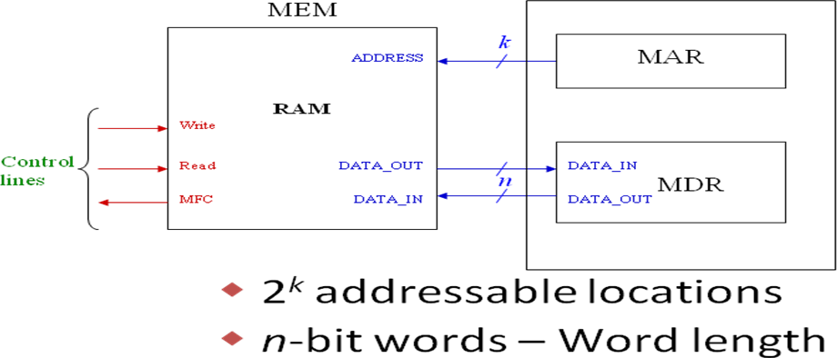

Readoperation

  - ForRead operation theaddresshastobesenttoMARwhichis being carried outbythe address bus then the READ signal is sent to thememory for read function.
  - ThememorytransfersthecorrespondingwordfromthespecifiedlocationtotheMDR through data bus.
  - Dropthememoryreadcontrolsignaltoterminatethereadcycle.

  - After the completion of theRead Operation the memory transfer MFC (Memoryfunction completed signal).

Writeoperation
  - ForwriteoperationtheCPU specifythelocationtoMAR anddatatoMBR/MDR.
  - Then it transfers the Write control signal after which the data which is present in MDR istransfer to the memory.
  - AftercompletionofthewriteoperationmemorytransferMFCsignal.

Accesstime

Thedurationoftimebetweentheinitiationofreadsignalandtheavailabilityofrequiredwordinthe MBR is called as the access time or read time.

Writetime

Thedurationbetweenthewritesignalandstoringofthewordinthespecifiedlocationiscalledas writetime.

Memorycycletime: -

Itisnecessarythattheinformationshouldbewrittenbackfromwhereitwasread.Thedurationof read and write operation is called as memory cycle time.

SEMICONDUCTORRAM:-
Semiconductormemoriesareavailableinawiderangeofspeedandtheircycletimerangesfrom 100 ns to less than 10ns.
ORAGANISATIONOFMEMORYCHIP:-
Memorycellsareorganizedintheformofanarrayofcells,eachcellcapableofstoringonebitof information.
  - Eachrowofcellsconstitutesamemorywordof8bitsb0-b7andcellsofarowareconnected to a commonsignal line called “wordline”, whichis driven bytheaddress decoder.
  - Two‘bitlines'connectthecellsineachcolumntoasense/writecircuit.

  - Thesense/writecircuitareconnectedtothedataI/Olines.
  - Duringa'Read'operation,thesecircuitsreadtheinformationstoredandtransmitsthis information to the output data line
  - Duringa'Write'operation,thesense/writecircuitreceiveinputinformationandstoreitinthe selected cell.
  - Thisfollowingorganizationofaverysmallmemorychipconsistingof8bitsof16wordsi.e., 16×8 organization.
  - ThedataI/Oofeachsense/writecircuitareconnectedtoasinglebidirectionaldatalinethat are connected to the data bus of the computer.

  - Inaddition,therearealsotwo controllinesR/WandCS(chipselect)
  - TheR/Wsignallinespecifies,therequiredoperationsandCSselectsagivenchipinmulti- chip memory system.
  - Thismemorycircuitstores128bitanditrequires14externalconnectionforaddressdataand control line. It also needs two lines for power supply and ground connection.
  - For a larger memory circuit let 1k(1024) memory cell can be organized as 128×8 memory requires 19 external connection.

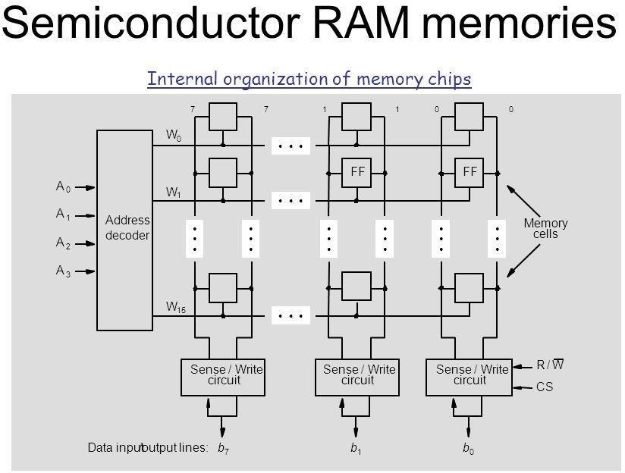
LATENCYANDBANDWIDTH:-
- Thespeedandefficiencyoftransferofwordorblocksbetweenmemoryandprocessor greatly affect the performance of a computer system.
- Therearetwoparameterlatencyandbandwidthgiveanindicationofperformanceof computer system.
LATENCY:-
- Theamountoftimeittakestotransferawordofdatatoorfromthememoryisreferred to a LATENCY of a memory.
- Latencyprovidesacompleteindicationofmemoryperformanceincaseofareadingor writing of a single word.
BANDWIDTH:-
Whentransferringablockofdataastheblocksizecanbevariable,theperformanceMeasures in terms of the number of bits or bytes that can be transferred in one second is known as BANDWIDTH of memory unit.

The bandwidth clearly depends upon the speed of access and no. of bits that can be transferredinparallel,sothe bandwidthisthe product ofdata transferredand the widthofdata bus.

ROM(READONLYMEMORY)
BothSRAMandDREAMchipsarevolatileinnatureastheylosethestoredinformationifthe power is removed.
- Manyapplications needmemorydevicestoretainthestoredinformationevenifpower is removed.
- Whenacomputeristurnedontheoperatingsystemsoftwarehastobeloadedfromthe disk into the memory.
- Thebootprogramisquitelargeandmostofitisstoredonthedisk,buttheprocessor should execute some instructions that loads the boot program; so, a small amount of non-volatile memory that holds the instruction which helps in loading the boot program from the disk.
- Since, it’s normal operation involves only reading of stored data , a memory of this type is called Read only memory.

Cachememory:-
  - Thespeedofmainmemoryisveryslowincomparetothespeedofprocessor.So,forbetter performanceahigh-speedmemoryisusedinbetweenmainmemoryandCPU.Thatisknown as cache memory.
  - Thecachememorycomesfromthewordcachemeaningtohide.
  - Thebasicideabehindacacheissimplei.e.,themostheavilyusedmemorywordsarekeptin the cache, when the CPU needs a word, it will first look in the cache, only if the word is not there, it goes to main memory.
  - Analysisofaprogramshowsthemaximumprogramexecutiontimespentinthoseportionsin whichmanyinstructionswereexecutedrepeatedlyasinloops,hencefortheexecutionofthe programsformsalocalizearea,hencefortheexecutionoftheprogramsformsalocalizearea, where the programsor instructionexecutedrepeatedly andthe remainder ofthe programs are executed relatively less frequently that is called locality of reference.
CACHEMEMORY

MAIN

PROCESSOR

Readoperation:-

  - WhentheCPUneedstoaccessmemory,thecacheisfirstsearched,ifthewordisfound,itor read, it is known as “cache hit”
  - Ifthewordisnotfound,thenthemainmemoryisreferredas“cachemiss”.
  - Whena“cachemiss”occurs,itinitiatestoaccessmainmemorytotransfertherequired byte
orwordfrommainmemorytocache.
  - Theperformanceofthecachememoryisknownashitratio.

Problem:-

CacheAccessTime=100hs
Mainmemoryaccesstimeis1000ns Hit Ratio=0.9
Findouttheaveragememoryaccesstime.
(Ans)Averagememoryaccesstime=cacheaccess+mainmemorytime
=h*cacheaccesstime+(1-h)*mainmemoryaccesstime Average Memory Access Time
=0.9*100+(1-0.9)*100
=90+100=190ns

Writeoperation:-

During readoperation, when the CPU finds a word in cache memory, then themain memory is not involved in the transfer. But in caseofwriteoperationthere aretwo waysofwriting.
- Writethroughpolicy.
- Writebackpolicy.

Write throughpolicy: -

The simplest andmost commonly used procedure is to update main memory with every memory write operationwith cachememory beingupdate in parallel. Thisis calledas writethrough policy.

Advantages:-
Thismethodisthemostimportantcharacteristicsofdirectmemoryaccesstransfer.

Writeback policy

  - If the cache follows this policy, then the cache is updated during write operation and thelocation is marked by a flag.
  - When the block of the cache containing the flagged word is required to transfer the main memory at that time it is updated in main memory.

Advantages

Wheneverthewordisupdatedseveraltimes,itisbetterto usewriteback policy.

Mapping
  - Thetransformationofinformationfrommainmemorytocachememoryisknownas Mapping.
  - Therearethreetypes ofmappingfunction
    - DirectMapping
    - AssociativeMapping
    - Set-associativeMapping
  - Toexplainthemappingprocedures,weconsider2Kcacheconsistingof128blocksof16 wordseach,anda64Kmainmemoryaddressablebya16-bitaddress,4096blocksof16 words each.

DirectMapping
  - Blockmofthemainmemorymapsontoblockcofcachememoryaccordingtoformulac=m mod no of block of cache memory
c=mmod128
  - By this formula the block o,128,256…. Of main memory will be loaded to 0 block of cache memory. Similarly block 1,129,257 …. of main memory will be loaded to 1 of CM and likewise.
  - ForthismappingtheCPUgeneratesaddressforcachememoryis 16bits.
  - Theaddressisdividedinto3parts.
    - Word
    - Block
    - Tag

Thebitpatternwillbe

Tag | Block | Word

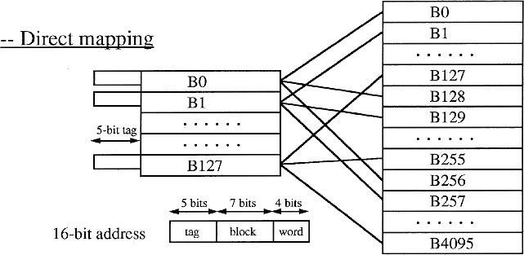
      - Oneblockcontains16words,so4bitsarerequiredtoindicatewordfield,cache contain 128 blocks so 7 bits are required to indicate block field and the rest 16- (7+4)=5 bits are required to indicate tag bit.
      - WhenCPUwantstoreadorwritethenthehigherorder5bitsoftheaddressarebeing compared with the tag bit of cache memory,
      - Ifitmatchesthenthedesiredwordispresentandacachehitoccurs.
      - Ifnot,therewillbeacachemisswhichleadstoawriteoperation.

Advantage

Simplestmethodofimplementation.

Disadvantage

Thecontentionproblemmayoccureventhoughthecacheisnot full.

Associative mapping

- Amainmemoryblockcanbeplacedintoanycacheblockposition.
- The12tagbitsidentifyamemoryblockresidinginthecache.
- Thelower-order4bitsselectoneof16wordsinablock.
- The cost of an associative cache is relatively high because of the need to search all 128 tags to determine whether a given block is in the cache or not.

Advantage:AnMMblockcanbemappedanywhereinCM.

Disadvantage:Sloworexpensive.Asearchthroughallthe128CMblocksisneededtocheck whetherthe12MSBsof the 16-bit address can bematched to any ofthe tags.

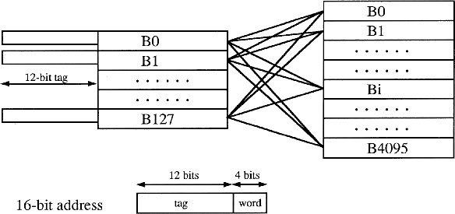

Set-AssociativeMapping:
- Blocksofthecachearegroupedintosets,andthemappingallowsablockofthemainmemoryto reside in any block of a specific set.
- Acachethathasknoofblockspersetisreferredtoasak-wayset-associativecache.
- Thecontentionproblemofthedirectmethodiseased.
- Thehardwarecostoftheassociativemethodisreduced.

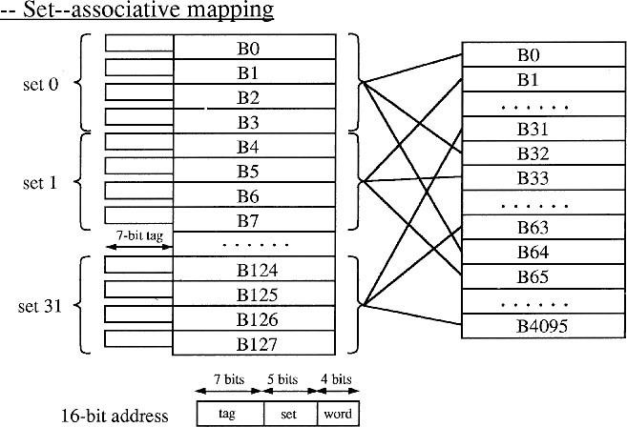

InterleavedMemory
- Thetwokeyfactorsin thesuccessofcomputerareperformanceandcost.
- Thiscanbeachievedthroughparallelism.
- In parallel processing or pipeline environment, the main memory is the prime system resources, which is normally shared by all processor or stages of the pipeline.
- In such cases there may be memory interference, which as a result degrades the performance. So, to avoid this problem, a new method is adopted which is known as “Memory interleaving”.
- The Memory interleaving means the main memory of the computer into a no of modules and distributing the address among those modules.
- Each memory module has its own Address Buffer Register (ABR)or Memory Address Register (MAR) and Data Buffer Register (DBR) or Memory Buffer Register (MBR).
- Therearetwomemoryaddresslayouts:
  - Highorderinterleaving(Consecutivewordsinamodule)
  - Loworderinterleaving(consecutivewordsinconsecutivemodule)
- The address consists of :(1) (2) low-order m-bits point to a particular word in that module
HIGHORDERINTERLEAVING:-
InthistypeofmemoryINTERLEAVINGthememoryisdividedintoMno.ofmoduleswherethe consecutive address lies in a single module.
- Inthismethodthehigherorderbitoftheaddressusedforindicatingthemoduleno.andthe lower order bits are used for indicating the address inmodule.
- Letforexamplewehaveamemoryhaving16words.
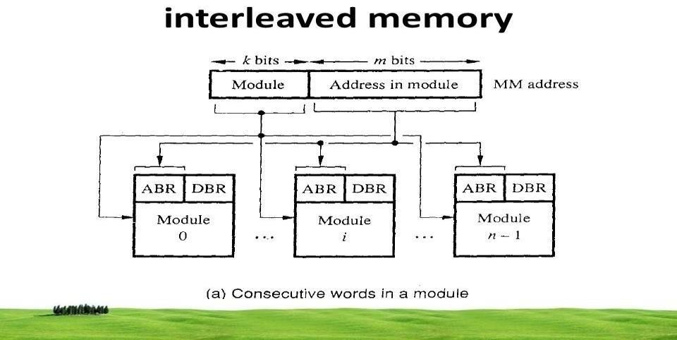

- Intheabovecasethehigherorderbitsusedforindicatingthemoduleno.andthelowerorder bits are used for the words in the module .
- Inthiscaseeachmemoryaddressisofnbitoutofwhichthehigherordermbitsareusedfor interleaving and n-m bits are used for the words in particular module.
- Thembitsarebeingdecidedbythedeciderwhichwillspecifytheparticularmoduleno.and n-m bit specify the words in the module .
- EverymemorymodulehasitsownMARandMBR.
Advantage:-
- Itpermitseasyexpansionofmemorybyadditionofoneormorememorymoduleasneeded to a maximum of m-1.
- Bettersystemreliabilityincaseofafailedmoduleasitaffectsonlyalocalizedareafaddress space.
Disadvantage:-
- Whenconsecutivelocationistobeaccessedthenonlyonemoduleisinvolved.
LOWORDERINTERLEAVING:-
Inthismemoryinterleavingtheconsecutivewordsaredistributedinconsecutivemodules.
- Herethehigherordern-mbitsareusedforaddressofwordsinamodulewhilemlowerbits are used for module no. .
- Thismethodisefficientwaytoaddressthemodule.
- Hereanyrequestforaccessingconsecutivewordscankeepseveralmodulesbusyatthesame time ;this is faster than the previous one and so used frequently.
- Ex:-allhave16words.
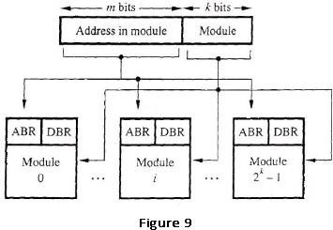

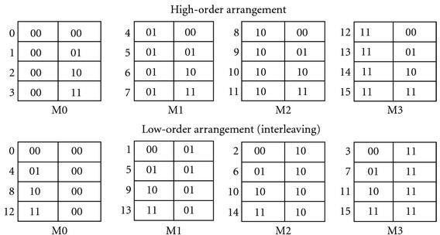

CHAPTER-5

Input–Output System

Introduction
- I/Ois an essential&integral partofcomputersystem. Varietyof I/Odevices onacomputer system - keyboard, mouse, display, magnetic disk, network adaptor, etc.
- I/O devicesdifferwidelyintermsoffunction,size, modeofoperation,transferspeed,power consumption, etc.
- All devices must be connected to the processor and memory using thesame basicarchitecture.
- Overtheyears,differentmechanismshavebeendevelopedtoconnectI/Odevicesto systems, and to program I/O data transfers over the resulting connections.

I/Ocontrollers
- AnI/Odeviceisconnectedtothecomputersystembyusinga
devicecontroller.
- I/Odevicesvaryinofsome orallofthefollowingcharacteristics:
- Representationofdata:voltage,current,magneticfield,etc.
- Speedofoperationanddatatransfer
- Timingandcontrolrequirements
- Needtodetectphysicalevents–e.g.,mouseclicksorkeypresses
- Needforerrordetectionandcorrection.
- To resolve these problems the computer system, include special hardwarecircuitsbetween CPU & peripherals. These are calledas interface unit. Each device has its own interfacing unit.
- Thepurposeofcommunicationallinkistosolvethefollowingproblems:
- Peripherals are electromechanical devices but CPU & memory are pure electronicdevices.
- DatatransferrateisslowerthanthatofCPU,sosynchronizationmechanismis required.
- Datacodesandformatsofperipheraldevicesdifferentfromthewordformatof CPU and memory.
- Operatingmodeofperipheralaredifferentfromeachother.Eachothermustbe controlled, so that it will not disturb the operation of others.

Interfacingbetweenperipheralsandprocessor

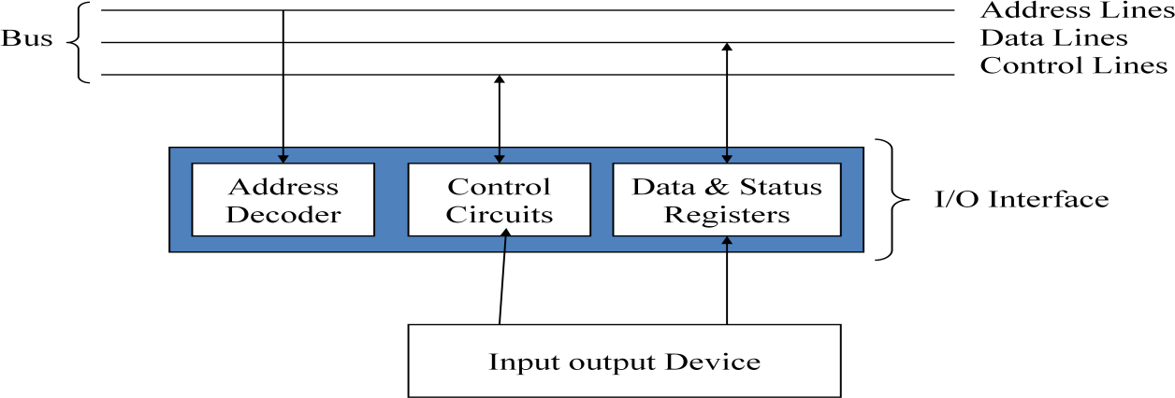

- Theabove diagram shows the communication link between the processor and peripherals devices.
- They are connected via the I/O bus. i/o busconsistof addressbus, controlbus, and data bus.
- Eachperipheralconsistsofitsowninterface.eachinterfaceattachedtotheinput output bus which contains an addressdecoder, that monitors the address line.
- When the interface detects its own address then it activates the path between the bus line and device. Rest lines are disabled.
- This is also called as input output command. Thefollowing command can be received.
  - Controlcommand-Thisisissued to activate the peripheraland toinform what to do.
  - Test command-this is used to test various status conditionin the interfaceand the peripherals.
  - Read command-it causes the interface to respond bytransferring the datafrom the bus into one of the registers.
  - Writecommand-thisisusedtoreceiveanitemofdatafrom peripheral device and place it in a buffer register.
- Alltheaboveprocessbeingaccompaniedbythecontrolcircuitofi/ointerface.
- After giving thecontrolcommand inthe controlline the CPUactivate the data bus. Then the data transfer takes place.
I\ooperationcanbedoneusing threetechniques.
- ProgrammedI/O
- InterruptdrivenI/O
- Directmemoryaccess

- Programmed I/O
  - InprogrammedI/O,dataareexchangedbetweentheprocessorandtheI/Omodule.
  - The processor directly controls of the I/O operation, including sensing device status, sending a read or write command, and transferring the data.
  - When the processor issues a command to the I/O module, it must wait until the I/O operation is completed .
  - AstheprocessorisfasterthantheI/Omodule,alotofprocessortimeiswasted.
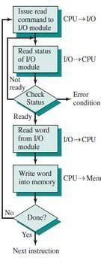

Interruptdriven I/O
    - The problem with programmed I/O is that the processor has to wait a long time for the I/O module of concern to be ready for either reception or transmission of data.
    - The solution to this problem is to provide an interruptmechanism. In this approach the processor issues an I/O command to a module and then go on to do some other useful work.
    - The I/O module then interrupt the processor to request service when it is ready to exchange data with the processor. Theprocessor then executes the data transfer. Oncethedata transfer isover, the processor then resumes its former processing.

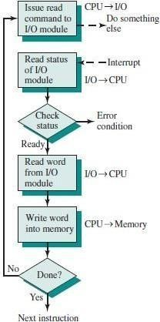

Processingofinterrupt
Interrupt
    - It is defined as an event external to the currently executing process that causes a change in the normal flow of instruction execution; usually generated by hardware devices external to the CPU.
    - During a processing of interrupt a no of events in both processor hardware and software are triggered by the interrupt.
    - Itisbeingcategorizedintoasbelow.

Hardware processing
Thesequenceof hardwareeventsthatoccur whenan i\odevice completesan operation are:
      - Aninterruptsignalisissuedbythei\odevicecontrollertotheprocessor.
      - The processor responds to the interrupt after finishingexecution of current instruction.
      - The processor sends an acknowledgement signal to the device that issuedthe interrupt.
      - Before processing the interrupt , processor saves the status in PSW andsaves the location of the next instruction to be executed in the program counter.
      - The processor now loads the PC with the address corresponding to the interrupt.

Software processing
      - The stack pointer is updated to point to the new TOS andthe PC tobeginning of interrupt service routine.
      - Theinterrupthandlerwillnextprocesstheinterrupt.
      - When the interrupt processing iscompletedthesavedregister valuesare restored .
      - ThePSWandPC valuesarefinallyrestoredfromthestack.
      - All the state of the program information about the ISR hasto be saved for future reference.
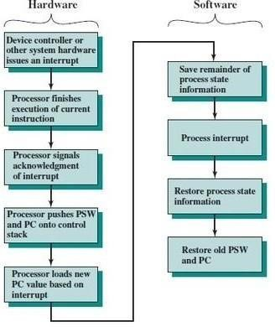

Methodsforhandlinginterrupt
- Everyinterrupthasitsserviceroutinetohandleit.
- Whenthe CPU getsanyinterruptsignal,itrespondstothe interruptbystoring the return address to a stack and the program branches to a service routine that process that interrupt.
- Aftersolvingtheinterrupt,theprocessorbacktotheoriginalprogram.
- As therearea number of i/o devices attached tothe computer, ata timemore thanoneinterrupt requestcanarise.In this casethesystemmust also decide which device to serve first.
- This problem can be solved by giving priority & the interrupt ofhigh priority device will be solved first.
- Theprioritycanbeestablishedbyhardware&softwaremethod.

Polling
Polling(S/W)
Daisy chaining(H/W)
Daisy chaining(H/W)
Polling(S/W)
Handlingmechanism
- Pollingisasoftwaremethodwhichidentifiesthehighestprioritysource.
- The highest priority source is tested first & if its interrupt signal is on then controls branches to a service routine for theservice. Otherwise, the next lowerpriority is tested and so on.
- Butthisisslower.

Daisy chaining
- Itisahardwaremethod.
- Daisy chaining consistsof a several connectionsof all devicesthat request aninterrupt.
- Thedevicewithhighestpriorityisplacedinthefirstpositionfollowed by lower priority which is placed the last of the chain

Directmemoryaccess
- ThedatatransferbetweentheprocessorandI/OdevicesnamelyprogrammedI/O and Interrupt-driven I/O, both the methods require the active intervention of the processor to transfer data between memory and the I/O module, and any datatransfer must traverse a path through the processor.
- To transfer large block of data at high speed, a special control unit may be providedto allow transfer of a block of data directly between an external device and the main memory, without continuous intervention by the processor. This approach is called direct memory access or DMA.
- DMA module is capable of taking over control of the system fromthe processor to transfer databetween I/O and memory overthe system bus ,this is donebyallocating the bus when the processor is not using it.
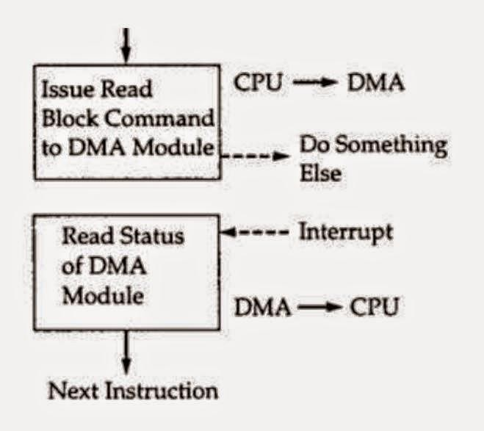

Operationof DMAmodule
- DMA transfers are performed by a control circuit associated with the I/O device and this circuit is referred as DMA controller.
- WiththehelpofReadorWritecontrolline,aspecificoperationisrequested.
- I/o device which wantsto send data ,DMAsendsa HOLDsignal toCPU onreceiving HOLDsignalitsendsaHOLDACKtothei/odevice indicatingthatithasreceived it.
- The address of the I/O device and the starting location in memory need to be Read/WriteiscommunicatedontheaddresslineandstoredbytheDMAmodule in the addressregister.
- The number of words to be transferred is communicated on the data lines and storedin the data counter register.
- On the completion of the transfer of data DMA module sends an interrupt signal tothe processor.
- DMAdatatransferschemeareoffollowingtwotype-
  - BurstMode
  - CyclestealingMode.

Burstmode
Thisis themostcommontype ofDMAused.InthismodeI/odevice withdraws the DMA request only after all data bytes aretransferred.

Cyclestealing
In this mode a block of data is transferred by a sequence of DMA cycle.Here the I/O device withdraws DMA request after transferring one or several bytes.
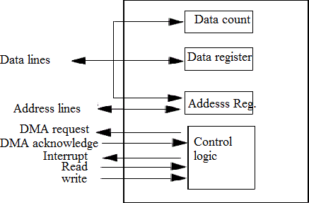

CHAPTER-6

I/OInterface&Bus architecture

BUSINTERCONNECTION
- Abusisacommunicationpathwayconnectingtwoormoredevices.
- Akeycharacteristicofabusisthatitisasharedtransmissionmedium.
- Multipledevicesconnecttothebus,andasignaltransmittedbyanyonedeviceisavailable for reception by all other devices attached to the bus (broadcast).
- Typically,abusconsistsofmultiplecommunicationpathways,orlines.Eachlineiscapable of transmitting signals representing binary 1 and binary 0.
- Taken together, severallines ofa bus can be usedtotransmit binary digits simultaneously (inparallel). For example, an 8-bil unit ofdata can betransmitted overeight bus lines.
- Computer systems contain a number of different buses that provide pathwaysbetween components at various levels of the computer system hierarchy.
- A bus that connects major computer components (processor, memory, I/O) is called a system bus.Themostcommoncomputerinterconnectionstructuresarebasedontheuse of one or more system buses.

BUSSTRUCTURE
A system bus consists, typically, of from about 50 to hundreds of separate lines. Each line is assigned a particular meaning or function. Although there are many different bus designs, onany bus the lines can be classified into three functional groups data, address, and control lines.Inaddition,there may hepower distributionlines thatsupply power to the attachedmodules.

DataBus
- Provide a path for moving, data between system modules. These lines, collectively,are called the data bus.
- Thewidthofthedatabus:Thedatabusmayconsistoffrom32tohundredsofseparatelines, thenumberoflinesbeingreferredtoasthewidthofthedatabus.Becauseeachlinecancarry only 1 bit at a time, the number of lines determines howmany bits can be transferred at a lime. The widthofthe databus isa key factorindeterminingoverall system performance. For example, if the data bus is 8 bits wide and each instruction is 16 bits long, then the processor must access thememorymodule twice during each instruction cycle.
- Asdatabuscarryinformationfromandtothemodules,soit isbidirectionalinnature.

AddressBus
- Addresslinesareusedtodesignatethesourceordestinationofthedataonthedatabus.For example,ifthe processorwishestoreadaword(8,16. or32bits) of data frommemory,it puts the address of the desired word on the address lines.
- The width of the address bus: determines the maximum possible memory capacity ofthe system.Furthermore, theaddress lines are generally also used toaddress I/O ports.

ControlBus
- Control bus areused to control the access to and theuseofthe dataand address lines. Because the data and address lines are shared by all components, there mustbe a means of controlling their use.
- Control signals transmit both command and timing information between system modules.

Typicalcontrollinesincludethefollowing:
- Memorywrite:Causesdataonthebustobewrittenintotheaddressedlocation.
- Memoryread:Causesdatafromtheaddressedlocationtobeplacedonthebus.
- I/Owrite:CausesdataonthebustobeoutputtotheaddressedI/Oport.
- I/Oread:CausesdatafromtheaddressedI/Oporttobeplacedonthebus.
- TransferACK:Indicatesthatdatahavebeenacceptedfromorplacedonthe bus.
- Bus request:Indicatesthatamoduleneedstogaincontrolof thebus.
- Busgrant:Indicatesthatarequestingmodulehasbeengrantedcontrolofthebus.
- Interruptrequest:Indicatesthataninterruptispending.
- InterruptACK:Acknowledgesthatthependinginterrupthasbeenrecognized.
- Clock:Usedtosynchronizeoperations.
- Reset:Initializesallmodules.
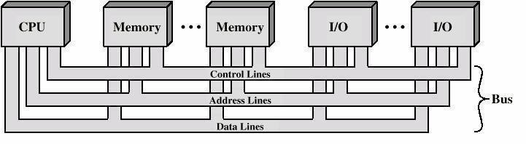

MULTIPLE-BUSARCHITECTURE
If a great number of devices are connected to the bus, performance will suffer. There are two main causes:
- Propagationdelay-thetime ittakesfordevicestocoordinatetheuseofthebus
- Thebusmaybecomeabottleneckastheaggregatedatatransferdemandapproachesthe capacity of the bus (in available transfer cycles/second).
  - Accordingly,mostcomputersystemsusemultiplebuses,generallylaidoutina hierarchy.
Therearemainlytwotypicalarchitecture:1)TraditionalBusarchitecture,,2)HighperformanceBus architecture

TraditionalBusarchitecture
- Thisconsistsof threebuses,likelocalbus,systembusandexpansionbus
- Thereisalocalbusthatconnectstheprocessortoacachememoryandthatmaysupport one or more local devices.
- Thecachememorycontrollerconnectsthecachenotonlytothislocalbus,buttoasystem bus to which are attached all of the mainmemory modules.
- ItispossibletoconnectedI/Ocontrollersdirectlyontothesystembus.Amoreefficient solution is tomake use of one or more expansionbusesfor this purpose.
- AnexpansionbusinterfacebuffersdatatransfersbetweenthesystembusandtheI/O controllers on the expansion bus.
- ThisarrangementallowsthesystemtosupportawidevarietyofI/Odevicesandatthesame time insulate memory-to-processor traffic from I/O traffic.

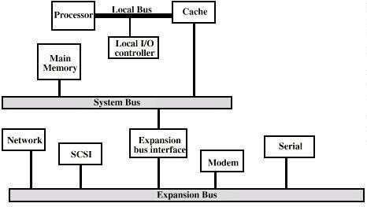

HighperformanceBusarchitecture
- Duetotheincreasingneedforaddingmorei/odevicesthetraditionalarchitecturecannot support so, it is necessary to build a high-performance bus.
- Similar to the traditional bus architecture, this too contains a local bus that connectsthe processortoacachecontroller,whichinturnisconnectedtothemainmemorythroughthe system bus.
- Thecachecontrollerisintegratedintoabridgeorbufferingdevicethatconnectstothe high-speed bus, which sometimes referred to as Mezzanine Architecture.
- Thisbussupportstohigh-speedLANs,videoandgraphicsworkstationcontrollersetc.
- Thelowerspeeddevicesarestillsupportedbytheexpansionbuswithaninterfacebuffering traffic between the expansion bus and high-speed bus.
- Thiswaythehigh-speeddevicesaremorecloselyintegratedwiththeprocessorthroughthe high-speedbus and at the sametimeleaving processor independent.
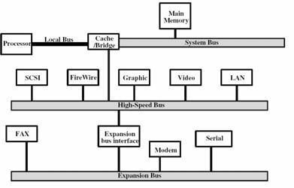

BASIC PARAMETERSOFBUSDESIGN
Beforedesigningabussomeofthefollowingbasicparametersaretobeconsidered
- Bustype
- Widthofthebus
- Methodofarbitration
- Timing
- Datatransfer

Bustype
- Buslinescanbeseparatedintotwogenerictypes:dedicatedandmultiplexed.
- Adedicatedbuslineispermanentlyassignedeithertoonefunctionortophysicalsubset of computer components.
- Separatedata&addresslines areused.
- Theuseofthesamelinesformultiplepurposesisknownas Multiplexing.
Sharedlines
- Addressvalid or datavalidcontrollinesareused.

Widthof thebus
- Thewidthofthedatabushasanimpactonthesystemperformance
- Thewiderthedatabus,thegreaterthenumberofbitscanbetransferredatonetime.
- Thewidthoftheaddressbushasanimpactonthesystemcapacity.
- Thewidertheaddressbus,thegreatertherangeoflocationsthat canbereferenced.

Method ofarbitration
Itdeterminingwhocanusethebusataparticulartime
- Centralized - a single hardware device called the bus controller or arbiter allocatestime on the bus
- Distributed - each module contains access control logic and the modules acttogether to share the bus
- Both methods designate one device (either CPU or an I/O module) as master, whichmay initiate a datatransfer with some other device, which acts as a slave.

Timing
SynchronousTiming
- Busincludesaclocklineuponwhichaclocktransmitsaregularsequenceofalternating1’s and 0’s of equal duration
- Asingle1-0transmissionisreferredtoasaclockcycleorbuscycle
- Allotherdeviceson the buscan read theclockline, and alleventsstartatthebeginning of a clock cycle

AsynchronousTiming
- Theoccurrence of oneevent onabusfollows and dependsontheoccurrence of aprevious event

Datatransfer
Abuscansupportvarioustypeofdatatransfersuchas-
- Read,Write,Read-modify-write,Read-after-write,Block
- Allbusesmustsupportwrite(mastertoslave)andread(slavetomaster)transfers.
- Read-modify-write:Areadfollowedimmediatelybyawritetothesameaddress.

- Addressisonlybroadcastonce,atthebeginningoftheoperation
- Read-after-write: Indivisible operation consisting ofa write followedimmediatelybyareadfromthesameaddress(forerrorcheckingpurposes)

SCSI
.
- Block:oneaddresscyclefollowedbyndatacycles
- firstdataitemtoorfromspecifiedaddress
- Remainingdataitemstoorfromsubsequentaddresses.

The Small Computer System Interface (SCSI) is a set of parallel interface standards developed by the American National Standards Institute (ANSI) for attaching printers, disk drives,scanners and other peripherals to computers. SCSI (pronounced "skuzzy")is supported by all major operating systems.
Ithassomeversionsdeveloped–
SCSI-1 is the original SCSI standard developed back in 1986 as ANSI X3.131-1986.SCSI-1 is capable of transferring up to eight bits a second.
SCSI-2 wasapprovedin1990, added new featuressuch asFastandWide SCSI,and support for additional devices.
SCSI-3wasapprovedin 1996asANSIX3.270-1996.

USB(UniversalSerialBus):
- Universal Serial Busisanewconnectorthatisintroduced1995toreplaceSerialandParallel ports.
- Itisbasedonserialtypearchitecture.However,itismuchquickerthanstandardserialportsbecause Serial architecture gives the interface a much higher clock rate than a parallel interface and serial cables are much cheaperthan parallel cables.
- So, from 1995, the USB standard has been developed for connecting a wide range ofdevices like scanners, keyboards, mice, joysticks, printers, modems and some CD- ROMs.
- USB is completely hot-swappable thatmeans wecan connectordisconnectanydevice when the computer is running.
- Computercanrecognizethedeviceassoonasitpluggedin,andtheusercanuseofthedevice immediately.
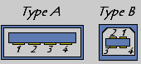
- TherearetwotypesofUSBconnectors:
  - Type A: This type of connectors is generally used for less bandwidth intensive devices like keyboard, mouse, webcam, etc. and shape is rectangular.

  - Type B: This type of connectors is generally used for high-speed devices like externalhard disks, etc. and shape is square.

PCI:
- Standsfor"PeripheralComponentInterconnect."ItisahardwarebusdesignedbyIntelaround1992 and is used in both PCs and Macs.
- Itisanintermediatebuslocatedbetweentheprocessorbus(Northbridge)andthe I/Obus (Southbridge).
- Mostadd-oncardssuchasSCSI,Firewire,andUSBcontrollersuseaPCIconnection.Some graphics cards use PCI, butmost new graphics cards connect to the AGP slot.
- PCIslotsarefoundinthebackofthecomputer.ThePCIinterfaceexistsin32bits witha124-pin connector or in 64 bits with a 188-pin connector.
- There are also two signalingvoltage levelsi.e.,3.3V for laptopcomputers and5V fordesktop computers.The64-bitPCIconnectorsofferadditionalpinsandcanaccommodate32-bitPCIcards.
- Thereare2typesof64-bitconnectors.Theyare64-bitPCIconnector,5Vand64-bitPCIconnector, 3.3V.

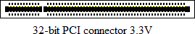
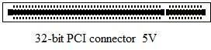
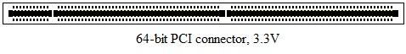

CHAPTER-7

ParallelProcessing
With the increased use of computers in every sphere of human activity, computerscientists are faced with two crucial issues today.
- Processinghastobedonefasterlikeneverbefore
- Largerorcomplexcomputationproblemsneedtobesolved

  - Parallelprocessingorcomputingisaformofcomputationinwhichmanyinstructionsarecarried outsimultaneouslyoperatingontheprinciplethatlargeproblemscanoftenbedividedintosmaller ones, which are then solvedconcurrently (in parallel).
  - Insteadofprocessingeachinstructionsequentiallyaparallelprocessingsystemisabletoperform concurrent data processing to achieve faster execution time
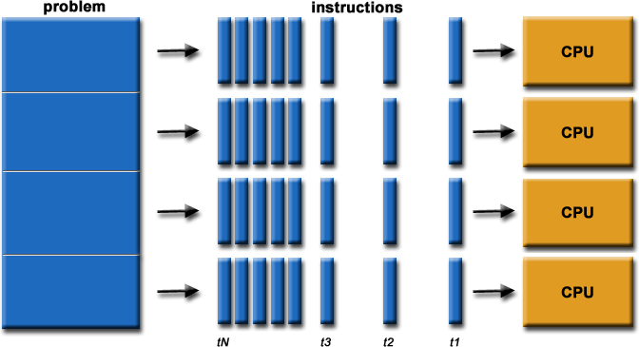

- ParallelComputingisusedforthefollowingreason
  - Savestime
  - Solvelargerproblems
  - Costsavings
  - ProvideconcurrencyItisbroadlycategorizedintoFourtypes

Bitlevelparallelism
Whenan8-bitprocessorneedstoaddtwo16-bitintegers,it’stobedone intwosteps.
    - Theprocessormustfirstaddthe8lower-orderbitsfromeachintegerusingthestandard addition instruction,
    - Thenaddthe8higher-orderbitsusinganadd-with-carryinstructionandthecarrybitfrom the lower order addition

InstructionLevelParallelism
Theinstructions given to a computer for processing can be divided into groups, orre-ordered and then processed without changing the final result. This is known as instruction-level parallelismi.e., ILP.
- e=a+b
- f =c+ d
- g=e*f
Here, instruction 3 is dependent on instruction 1 and 2 . However, instruction 1 and 2 canbe independently processed.

Taskparallelism
Task Parallelism focuses on distribution of tasks across different processors. It is alsoknown as functional parallelism or control parallelism

DataParallelism
Data parallelism focuses on distributing the data across different parallel computing nodes. Itis also called as loop-level parallelism.
Parallel processing can be achieved by using 3 technologies. 1.pipelining 2.Vector processing3.Array processing

Linearpipeline
The processofexecutionofinstructioncanbedividedinto4majorsteps.
1.Instruction Fetch(IF) 2.Instruction Decode(ID)3.Operand fetch(OF) 4.Execute(EX)
- DuringIFtheinstructionisfetchedfrommainmemory.
- DuringIDthe operationisidentifiedthatistobeperformed.
- DuringOFtheoperandisfetchedfrommemory(ifrequired).
- DuringEXtheinstructionisexecutedby ALU
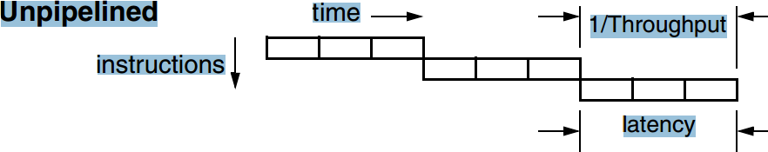
Inunpipelinedcomputerallthesefourstepsmustbecompletedbeforestartingofthenext instruction.
Butincaseofapipelinedcomputersuccessiveinstructionareexecutedinanoverlappedfashion.

- Itdecomposesasequentialprocessintosegments.
- It dividesthe processorintosegmentprocessors eachone is dedicatedtoaparticularsegment.
- Each segment is executedin a dedicated segment-processor operatesconcurrently with all other segments.
- Informationflowsthroughthesemultiplehardwaresegments.
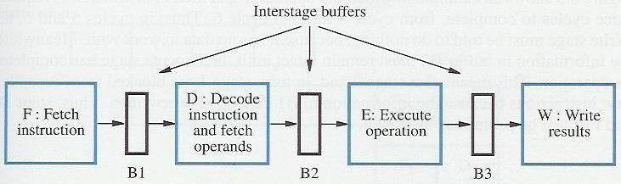

- Instructionexecutionisdividedintoksegmentsorstages
- Instructionexitspipestagek-1andproceedsintopipestagek
- Allpipestagestakethesame amountoftime;calledoneprocessorcycle
- Lengthoftheprocessor cycleisdeterminedbytheslowest pipestage
- Thereisainterstagebufferbetweentwosuccessivestages.
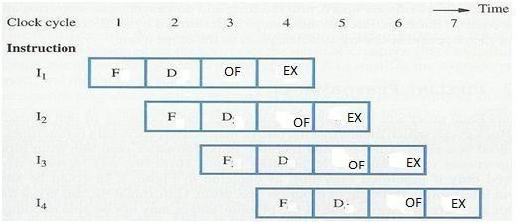

FLYNN’STAXONOMY
- Ingeneral,digitalcomputersmaybeclassifiedintofourcategories,accordingtothemultiplicityof instruction and data streams.
- ThisschemeforclassifyingcomputerorganizationswasintroducedbyMichaelJ.Flynn.The essentialcomputingprocess istheexecution of asequenceof instructionson asetof data.
- The term stream is used here to denote a sequence of items (instructions or data) asexecuted or operated upon by a single processor.
- Aninstructionstreamisasequenceofinstructionsasexecutedbythemachine
- A data stream is a sequence of data including input, partial, or temporary results, called for the instruction stream. Listed belowareFlynn’sfour machine organizations:

Singleinstructionstreamssingledatastream(SISD)
SISD computer organization This organization represents most serial computers available today. Instructions are executed sequentially but may be overlapped in their execution stages.



Singleinstructionstreamsmultipledatastream(SIMD)
SIMD computer organization: In this organization, there are multiple processing elements supervised by the same control unit. All PE’(processing element) receive the sameinstruction broadcast from the control unit but operate on different data sets from distinctdata streams.
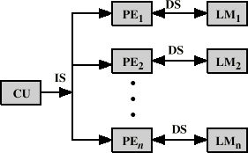

Multipleinstructionstreamssingledatastream(MISD)
MISD computer organization There are n processor units, each receiving distinct instructions operating over the same data stream. The results (output) of one processor become the input (operands) of the nextprocessor .This approach has no practical implementation.
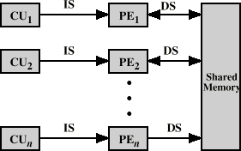

Multipleinstructionstreamsmultipledatastream(MIMD)
MIMDcomputerorganizationMostmultiprocessorsystemsandmultiplecomputersystems

can be classified in this category. MIMD computer implies interactions among the n processors because all memory streams are derived from the same data space shared byallprocessors.
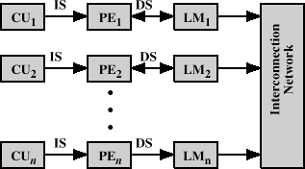

MULTIPROCESSOR
  - A multiprocessor system is an interconnection of two or more CPUs with memory & i\o equipment.Theprocessor in multiprocessor can have either CPUor i\oprocessor.
  - Computersareinterconnected witheach otherbymeans ofcommunicationlinestoforma computernetwork.Thenetworkconsistsofseveralautonomouscomputerthatmayormay not communicate with each other.
  - A multiprocessor system is controlled by one OS that provides interaction between processor & all the components of thesystem cooperate inthe solution of aproblem.
  - Multiprocessorareclassifiedbythewaytheirmemory isorganized.
    - Tightlycoupled
    - Looselycoupled.

Tightly coupled
These systems contain multiple CPUs that are connected at the bus level. These CPUs may have access to a central shared memory (SMP or UMA), or may participate in a memory hierarchy with both local and shared memory (NUMA).

Looselycoupled
These systems are based on multiple standalone single or dual processor or commodity computers interconnected via a high-speed communication system .
Each PE has its own private local memory. The processor is tied together by a switching scheme designed to route information from one processor to another through a message passing system.

